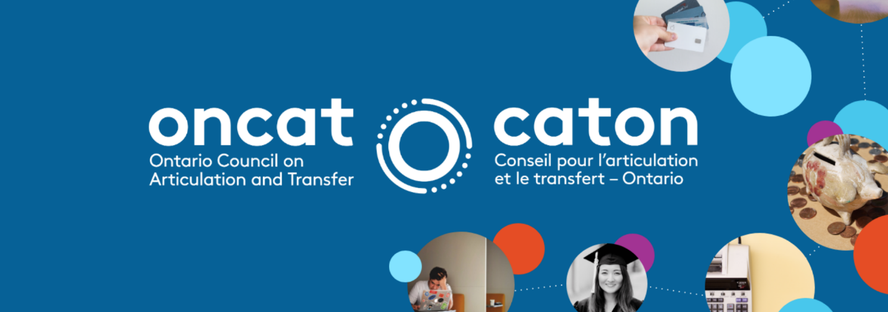
PROJECT SNAPSHOT
Trading Places: The Flow of Students into and out of
Apprenticeship Programs

Type: Research
Project Number: 2021-42 or R2142
Project Lead: McMaster University
Principal Investigator: Dr. Nicole Malette, Dr. Karen Robson

Project Summary
Apprenticeships provide alternative education pathways for a significant proportion of the Canadian population. In 2019 there were 77,573 Canadians enrolled in apprenticeship programs (Statistics Canada, 2019). A typical apprenticeship involves a contract between an employer and a student, under which the student agrees to receive a relatively low wage in return for training from one or two journeypersons (Gunderson & Krashinsky, 2015). Provincial governments and private industries continually favor the expansion of apprenticeship programming (Brown, 2020; CBC, 2020). However, there remains a decline in the number of students enrolling and completing apprenticeships over the past decade (Statistics Canada, 2020). Despite employment and economic growth in recent years, the number of newly certified tradespersons through apprenticeships declined 3.9% in 2019 (Statistics Canada, 2020). Changes to the Canadian economy contribute to this drop, including an expanding knowledge economy and local economic instability. However, little is known about the reasons students transfer into apprenticeship programs or the educational pathways of former apprenticeship students. Similarly, very little is known in Canada about students with university or college education who transfer into apprenticeship programs, either before or after completing their degrees/diplomas. There is no national database on these transfer pathways or on the ability to apply credits across programming (Missaghian, 2020). Although a small but growing literature on this phenomenon in Europe (see Pilz, 2009; Fuller & Unwin, 2012; Dismore, 2014), no study to date has explored the transfer process of moving between apprenticeships and college/university – in either direction.

To address this knowledge gap, we propose a one-year project that will advance current understandings of apprenticeship students’ educational pathways. Our project has three main aims:

- Explore the economic, social and emotional challenges effecting former apprenticeship students’ decisions to transition to college/university: How is the decision to transfer to college/university directly impacted by economic, social and emotional challenges faced by former apprenticeship students?
- Explore the academic, economic, social and emotional challenges effecting former college and university students choosing to transition to apprenticeship programs: How is the decision to transfer to apprenticeship programs directly impacted by economic, social and emotional challenges faced by undergraduate students?
- Understand the transfer processes explored by students who moved in either direction. Were their previous credentials recognized in their new chosen pathway? To answer our questions around the transfer from apprenticeships to postsecondary institutions and vice versa, we will collect interview data from 15 Ontario-based former apprentices who left to attend college or university (not connected to their apprenticeship program) as well as 15 former college or university students who left their postsecondary institution to pursue apprenticeships. Analysis of our interview data will allow us to identify mechanisms which influenced the participants’ choice of educational pathways. By documenting their transfer experiences, we will also be able to suggest targeted policies that can help address the challenges faced by former apprenticeship/undergraduate students in their educational transfer process. Our project will advance understandings of former apprenticeship/undergraduate students’ educational pathways and thereby aid the design and implementation of successful support strategies and continued education policies.

Project Rationale
There has been a steady decline in Canadian apprenticeship program enrolment and completion over the past decade. Expanding knowledge economies and local economic instability are two macro-social factors contributing to a decrease in apprenticeship participation. However, less is known about individual reasons for apprenticeship participation or early leaving. There is no data infrastructure that monitors the career pathways of individuals who chose an apprenticeship. Similarly, virtually nothing is known about students with university or college education who transfer into apprenticeship programs. To date, no study has explored the transfer processes of students moving between apprenticeships and college/university in Ontario.

Methods
We collected interview data from ten post-secondary administrators who work directly with transfer students. We also collected interview data from six Ontario-based students who transferred to university from apprenticeships and former apprenticeship students who transferred to apprenticeships. Analysis of our interview data allowed us to identify factors that influenced the participants’ educational pathway choices and experiences.

Describe any limitations

Due to sampling restrictions, we were not able to collect data from a representative sample of students who transferred into and out of apprenticeships in Ontario. While our interviews do demonstrate some of the challenges that students experience transferring through apprenticeship programming, they might not be representative of all students’ experiences.

Research Findings
We note several trends in the reasoning, challenges and benefits experienced by students who transfer into and out of apprenticeship programming.

Postsecondary Administrators
According to the postsecondary administrators we interviewed, students transferred into and out of apprenticeships for the following reasons:
- better employment opportunities;
- pursuit of personal interests; and
- difficulty finding apprenticeship partners.

Administrators also noted distinct institutional supports and deficits for students transferring into and out of apprenticeship programs:
- one-to-one academic advising (institutional support);
- online course transfer tools (institutional support);
- pre-existing transfer pathways (institutional support);
- lack of apprenticeship-specific support staff (institutional deficit); and
- lack of transfer policies (institutional deficit).

Transfer Students
Individuals who transferred into or out of apprenticeship programs also outlined their reasons for changing programs. However, unlike our administrator interviews, students only cited interest alignment as their reason for switching programs.

Students also provided examples of challenges and benefits experienced through their transfer process. Those challenges and benefits include:
- lack of apprenticeship-specific support staff (challenge);
- workplace culture (challenge and benefit); and
- concrete rewards (benefit).

Future Research
Further interviews with students across apprenticeship backgrounds about their reasoning for transfer would be helpful. However, both postsecondary administrators and students made suggestions for how postsecondary institutions could better support their transfer experiences. With these in mind, we created the following recommendations:
- Expand apprenticeship study areas.
- Provide more institutional support for apprenticeship partnerships.
- Raise awareness of databases that provide transfer pathway information to staff and students.
- Enhance secondary education-level supports for students wishing to pursue apprenticeships.

Student Outcomes
This study begins to uncover some of the challenges faced by students transferring into and out of apprenticeship programming. It is our greatest hope that the findings and recommendations provided in our report will support the creation of more transfer supports for these types of students. We also hope that greater support is provided for secondary students interested in pursuing apprenticeships and trades.

Institutional Outcomes
Some students noted that secondary school teachers and guidance councilors steered them away from pursuing apprenticeships after graduation. They noted that if there had been more support for trades and apprenticeships in secondary school, they would not have felt compelled to enter university coursework instead. Secondary and postsecondary cultures that discriminate against trades/apprenticeships may to limit the life chances of certain students.

Sector or System Implications
Some students and transfer administrators commented that access to an online database with information about transfer processes across Ontario schools would be helpful. ONCAT already provides this platform to all Ontario students and administrators. More publicity and acknowledgement about the resources already available to help transfer processes might be useful.

Tips
Unfortunately, due to the pandemic and frequent campus shut-downs, collecting interviews with administrators and students was extremely challenging. We reached out to more than 250 administrators across Ontario colleges and universities from spring 2021 to winter 2022. Administrators who responded to our requests commented that they were feeling overworked and stressed from the pandemic, and didn’t have time to complete an interview with us. Others noted that they didn’t see students transferring to or from apprenticeship programs. Student participants were also difficult to connect with, as many students were studying remotely and feeling equally overworked and stressed. To overcome these challenges, we would recommend that others interested in conducting research in this area establish on-campus relationships (if available).

