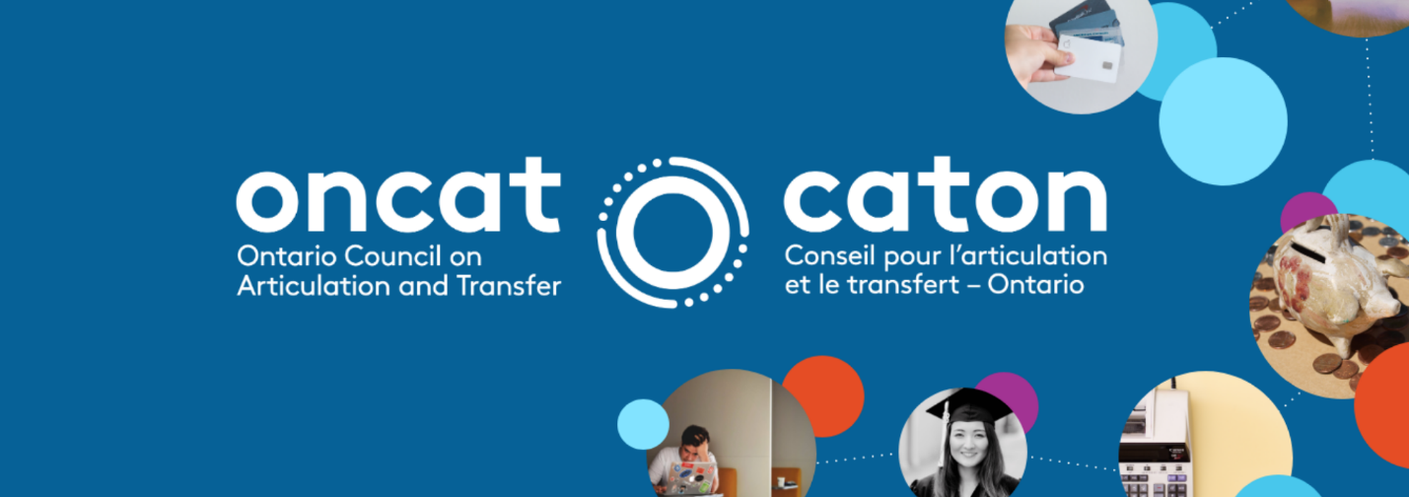
PROJECT SNAPSHOT
Nipissing University NSSE Analysis Project

Type: Research
Project Number: 2021-45 or R2145
Project Lead: Nipissing University
Principal Investigators: Heather Daoust (Institutional Analyst), Stephen Tedesco (Director, Institutional Planning and Analysis)

Project Summary
Through this project, Nipissing University will attempt to align – where possible – fields within the NSSE across the 2006, 2008, 2011, 2014, 2017 and 2020 iterations of the survey. The intent will be to pool observations across years to produce a large enough sample – across years – to analyze differences amongst students that started their post-secondary education at Nipissing with those that started their post-secondary education elsewhere.

Project Rationale
As was alluded to in the project overview, the NSSE had a significant overhaul between the 2014 and 2011 iterations. That being said, aligning NSSE 2006 through 2011 was a relatively simple task, as was the alignment of NSSE 2020 through NSSE 2014. The lion share of the work that this project aimed to accomplish was harmonizing NSSE 2014 with NSSE 2011.

Methods
Due to the relatively small size of Nipissing University, it was decided that once the NSSE surveys were harmonized then we could pool observations across years to analyze differences amongst students that started their post-secondary education at Nipissing with those that started their post-secondary education elsewhere.

Group differences were analysed for significance at the α = 0.05 level using an independent t-test for equality of means. Levene’s test for equality of variance was completed for each t-test and our results outline whether or not equal variances were assumed.

Describe any limitations

Limitations
The alignment of the six versions of the NSSE instrument did introduce some subjectivity in instances where questions did not have a direct alignment.

Another limitation specific to our NSSE data files was that there were three instances where fields aligned within the Canadian NSSE codebooks but responses were not included in the Nipissing data file(s) for a given year. This resulted in our sample size being restricted for these fields.
It should be noted (and is outlined in detail in the NSSE Version Alignment file), that there are some circumstances that even deriving/recoding values will not achieve perfect alignment through all iterations of NSSE. Here are some examples:
- Questions regarding number of papers and length (Q7); page count categories changed and overlapped previous categories.
- Questions regarding challenge to do best work (Q10); one significant likert scale value change restricts direct comparison of results (e.g., NSSE 2014: 1 = Not at all; NSSE 2011: 1 = Very little).
- Questions regarding Quality Interactions (Q13); descriptors on likert scale changed entirely.

Research Findings
Summary of Findings
ACADEMICS [Significance (α = 0.05)]
- Major Category
- Class Level
- Enrolment Status
- Online Courses
- Grades
- Living Arrangement
- Varsity Athletes
No Significance
  - Aspiration Level of Education

ENGAGEMENT [Significance (α = 0.05)]
- 41 measures of engagement were found to have significant group differences among those with and without PPSE.

With respect to Demographics and Academics, the categories in which we observed significant group differences didn’t come as much surprise to us. With respect to the Engagement indicators, there were some interesting observations. Generally speaking, students without PPSE tended to display more institutional satisfaction than those who had prior PPSE (see Q15, Q19, Q20). The same phenomenon was observed when evaluating institutional emphasis (see Q14). Conversely, students with PPSE tended to identify more prevalence of high-impact practices in their programming (Q2, Q4, Q6, Q8) than students without PPSE. As mentioned above, the entire analysis Nipissing’s NSSE data is outlined in Appendix A: Analysis of NSSE Results.

Future Research
Future Research
The scope of this project included basic significance testing of differences in responses between students with/without previous post-secondary education. We were able to identify key areas where significance was noted, but deeper investigation into these differences was outside the current scope. The base testing we have completed could be expanded upon to include further and more detailed data analysis. Another area of interest is to complete further analysis on those questions corresponding to high impact practices (HIPs) within the NSSE instruments. Pre and post 2012 versions of NSSE-defined HIPs did not align and so we were restricted in the number of responses available for further analysis in this area.

Student Outcomes
As far as prior learning experience is concerned, Nipissing is among the top five institutions in the province with respect to the number of undergraduate learners with previous post-secondary experience (PPSE).

Confirmation statistics from OUAC also illustrate that proportion of student acceptances that are assessed for advanced standing at Nipissing University is nearly five times greater than the sector (i.e. 28% for Nipissing vs. sector average of about 6%).
Research like this provide us deeper insight into Academic and Engagement differences amongst transfer students and will allow us to build the necessary supports to ensure their successful transition into their studies at the University.

Institutional Outcomes
The project specifications asked us to investigate the feasibility of linkages between NSSE and other available administrative data sources within Nipissing, in particular, our student information system and graduate KPI survey data.

Since we only began in this office in 2017 (and after NSSE 2017 was administered), we spent a considerable amount of searching through our digital records to find crosswalk files for each NSSE. We are happy to say that we have a full set of crosswalks for our NSSE data which means that we can directly link NSSE results to our administrative data (i.e., our SIS). Now that we have put in the work to source these crosswalks we look forward to the opportunity to work with ONCAT to investigate deeper linkages to improve the body of knowledge with respect to student transfer experiences at Nipissing.

